 **Introduction to DevOps**

**BCS/BS 6A**

Lab: 01

# GROUP MEMBERS:

MUHAMMAD SHAYAN SHAHID (2212325)

MUHAMMAD ASHAD BAIG (2212115)

Task 1: In the first step we are creating the virtual machine

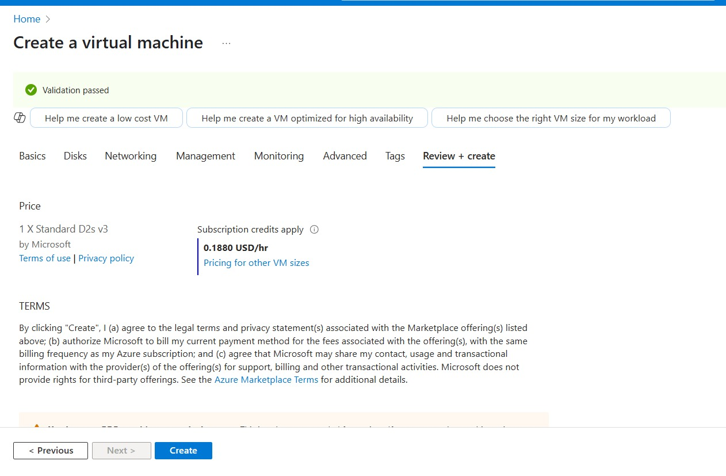

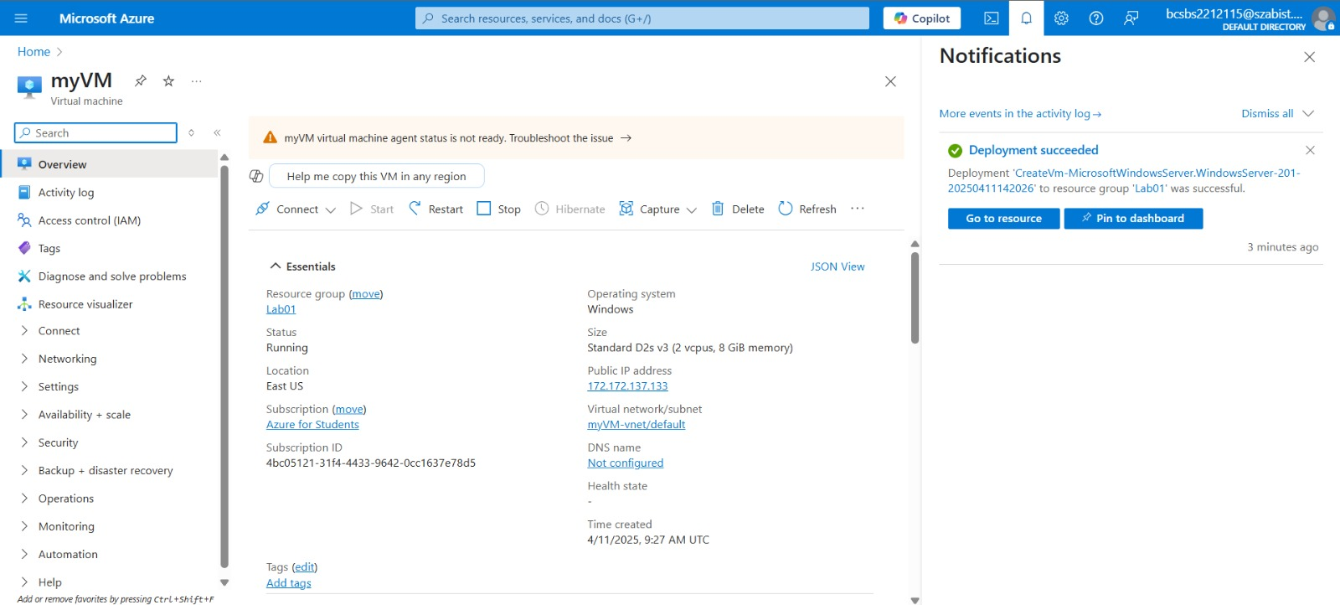

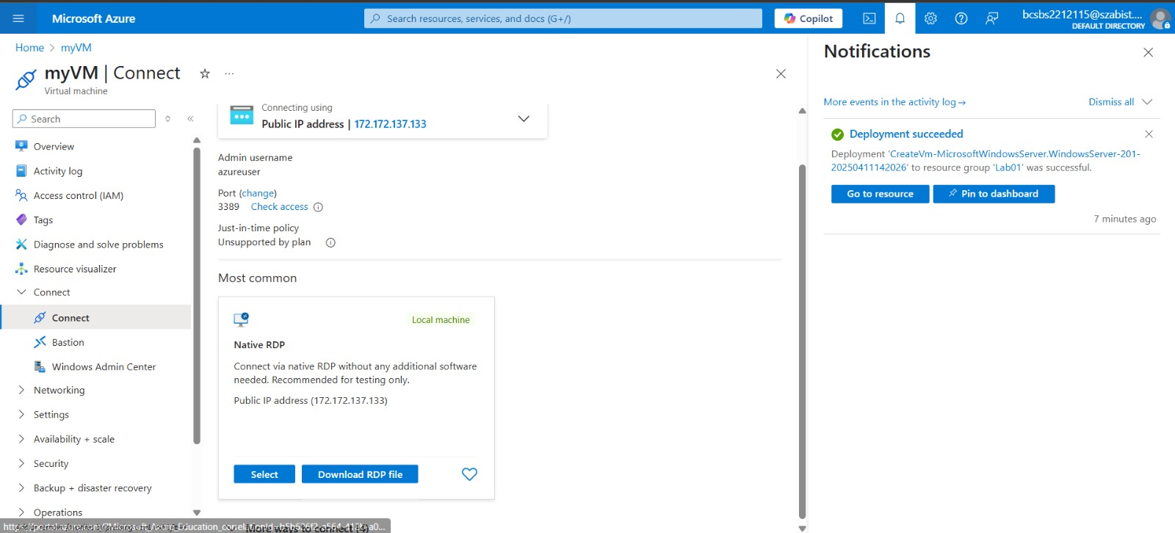



Task 2: we are connecting to the virtual machine In this task, we will connect to our new virtual machine using RDP (Remote Desktop Protocol).  
 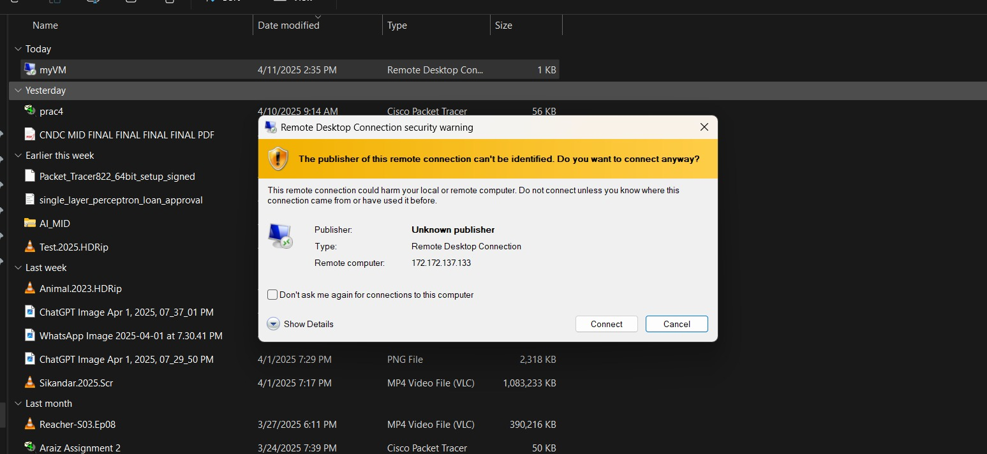

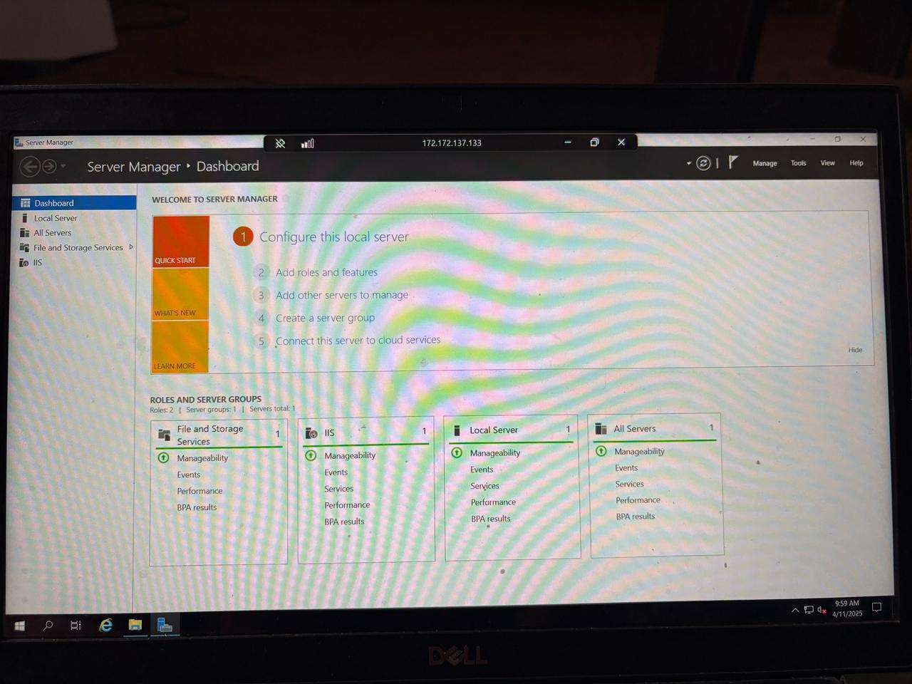

Task 3: we will Install the web server role and test In this task, install the Web Server role on the server on the Virtual Machine you just created and ensure the default IIS welcome page will be displayed.

Code: Install-WindowsFeature -name Web-Server -IncludeManagementTools

